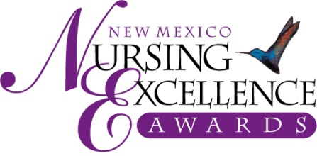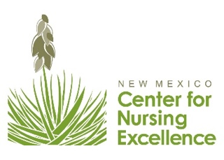
COVID-19 Response Team Award
2021 Nomination Criteria – For Review Only

“COVID-19 Response Team” Award | Healthcare organizations are encouraged to nominate teams within their organization who have gone above and beyond to ensure safe, high-quality, high-value, sustainable health care to respond to the COVID-19 pandemic. Nominees must include a nurse and may also include, though is not limited to, providers, pharmacists, nursing assistants, housekeeping, dietary services, medical assistants, technicians, environmental services, quality directors, board members and more—any who provide and/or impact direct care.

NOMINATION CRITERIA for “COVID-19 Response Team” Award

Please give specific examples of how this healthcare team worked together to deliver safe, high-quality, high-value, sustainable health care to respond to the COVID-19 pandemic.

- Innovation or responsive work. Nomination essay should highlight any and all ways that team’s response to pandemic enhanced safety, quality, value, or sustainability. (50% of scoring)
Consider highlighting the following:
    - Approach to ensuring patient safety amidst COVID-19
    - Demonstrate how patients’ and/or families’ experience was improved as a result of the team’s commitment
    - Developed sustainable processes to respond to the COVID-19 pandemic
    - Adapted pre-COVID care to COVID safe practices while providing quality patient care
    - Developed best practices that can be utilized outside of the public health emergency
    - Describe how other health care workers were positively impacted as a result of the team’s efforts
- Collaboration. Nomination essay should provide evidence of how the team worked collaboratively to achieve positive results. (50%)
Consider highlighting the following:
    - Provide examples of respectful team communication to address problems and constraints, including how consensus building and trust were developed and maintained within the healthcare team.
    - Provide examples of how disciplines and skill sets were maximized

Nominations are Due September 3, 2021

Only Online Submissions will be Accepted – Submit nominations at www.NMNursingExcellence.org/Nursing-Excellence-Awards

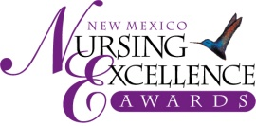

New Mexico Nursing Excellence Awards
Saturday, October 23rd, Hotel Albuquerque at Old Town
Silent Auction at 5:30 pm, Dinner & Awards at 7:00 pm

2021 COVID-19 Response Team Awards - Example Nomination

Healthcare organizations are encouraged to nominate teams within their organization who have gone above and beyond to ensure safe, high-quality, high-value, sustainable health care to respond to the COVID-19 pandemic. Nominees must include a nurse as their lead nominee. That nurse lead nominee will be invited to attend the Nursing Excellence Awards (NEA). The other team members may attend the NEA at a discounted rate of $75/each which covers the cost of their meal. The lead nurse nominee will be the primary point of contact with the Center for Nursing Excellence (receive congratulatory letter, emails about the NEA event, etc).

Information about Nominees

Nomination Category:

Nurse Lead Nominee Name: LAST Nurse Lead Nominee FIRST (no nicknames)

Employer/Organization Job Title

Degrees/Credentials (RN, LPN, etc.) Nominee NM resident 8/20-8/21? YES

(Consideration may be given to a nurse who is not a NM resident if that nurse is primarily employed in NM. Contact us at admin@nmcne.org with questions)
Complete Work Address

Personal Mailing Address
(We send congratulatory letter and would like to have lead nominee’s home address)

Daytime Phone Email (req.)

Team Member Nominee Name: LAST Team Member Nominee FIRST (no nicknames)

Employer/Organization Job Title

Team Member Nominee Name: LAST Team Member Nominee FIRST (no nicknames)

Employer/Organization Job Title

Team Member Nominee Name: LAST Team Member Nominee FIRST (no nicknames)

Employer/Organization Job Title

Team Member Nominee Name: LAST Team Member Nominee FIRST (no nicknames)

Employer/Organization Job Title

All Other Team Nominees Names/Employer/Job Title: (Short Paragraph)

Information about Nominator

Nominated By

Business/Organization/Affiliation

Nominator’s Complete Address

Daytime Phone Email

Instructions:
Please provide a summary of no more than 2 pages, double-spaced, describing why you feel this nominee deserves the Touch of Life Award. NOTE: If over 2 pages, only the first 2 pages will be eligible for review. Please give specific examples of how he or she impacted your life or the life of someone close to you. All qualified nominees will receive one free ticket to attend the New Mexico Nursing Excellence Awards celebration on Saturday, October 23rd.

Deadline for submission: September 3rd
In order for your nominee to be considered for this award, all information requested must be provided. This includes:

- 2-page summary of accomplishments (please try to address the criteria in telling your story)
- Payment of $75 nomination fee.

We list the criteria so you may address each one in your narrative.
Remember - specific examples are a great way to share the nurse’s contributions and show how the nurse meets the criteria.

Please note the percentage/weight given to each criterion and please address all criteria in writing your essay.

- Innovation or responsive work. Nomination essay should highlight any and all ways that teams response to pandemic enhanced safety, quality, value, or sustainability. (50% of scoring)
Consider highlighting the following:
    - Approach to ensuring patient safety amidst COVID-19
    - Demonstrate how patients’ and/or families’ experience was improved as a result of the team’s commitment
    - Developed sustainable processes to respond to the COVID-19 pandemic
    - Adapted pre-COVID care to COVID safe practices while providing quality patient care
    - Developed best practices that can be utilized outside of the public health emergency
    - How other health care workers were positively impacted as a result of the team’s efforts
- Evidence of how the team worked collaboratively to achieve positive results. (50%)
Consider highlighting the following:
    - Provide examples of respectful team communication to address problems and constraints, including how consensus building and trust were developed and maintained within the healthcare team.
    - Examples of continuous improvement processes
    - Examples of how disciplines and skill sets were maximized

