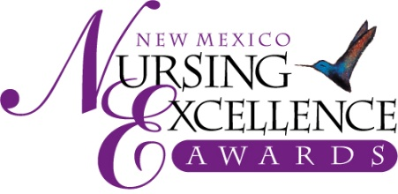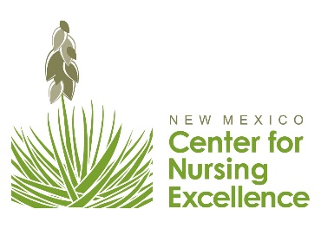

Community Service
2021 Nomination Criteria – For Review Only

Community Service Award | Recognition of a nurse who takes a leadership role in community organization and has made significant professional or voluntary contributions that have improved the profession or patient care in New Mexico.

NOMINATION CRITERIA for Community Service

1. How did this nurse contribute significantly through volunteer efforts in the community, e.g., local or state health care, educational, political, or nursing organizations? (30%)
- Takes part in numerous area outreach programs that have enriched the lives of
individuals and families

2. Did this nurse develop/implement an innovative prevention or intervention program or provide outstanding service as a volunteer to an organization that has a focused interest in nursing? (25%)

3. How did this nurse work collaboratively toward a common goal that benefited a patient/patient population or the profession? (20%)

4. How does this nurse encourage team cohesiveness and contribute to the healthcare team? (15%)

5. Is this nurse an active member of a regional, state, or national organization or on a board that has initiatives in healthcare? (10%)

NOTE: A nurse may not be nominated again in the same category in which they have won previously.

Nominations are Due September 3, 2021

Only Online Submissions will be Accepted – Submit nominations at www.NMNursingExcellence.org/Nursing-Excellence-Awards

New Mexico Nursing Excellence Awards
Saturday, October 23rd, Hotel Albuquerque at Old Town

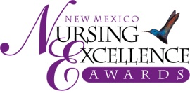

2021 Nursing Excellence Awards -Example Nomination
(Use this to review for nominations in community Services categories- This is NOT an application)
Deadline for submission: Friday, September 3rd

Information about Nominee

Nomination Category

Nominee Name: LAST FIRST (no nicknames) MI

Employer/Organization Job Title

Degrees/Credentials (RN, LPN, etc.) Nominee NM resident 8/20-8/21? YES

(Consideration may be given to a nurse who is not a NM resident if that nurse is primarily employed in NM. Contact us at admin@nmcne.org with questions)

Complete Work Address

Personal Mailing Address
(We send congratulatory letter and would like to have nominee’s home address)

Daytime Phone Email (req.)

Information about Nominator

Nominated By

Business/Organization/Affiliation

Nominator’s Complete Address:

Daytime Phone Email

Professional Reference
(Must be from the nominee’s current work organization)

Name:

Duty Title:

Organization: Daytime Phone: Email:

Nominee Biography
(Please confine information to this form. No attached resumes will be accepted.)

Nominee Name:
Credentials:
Present Position/Job Title:
Education (include basic preparation through highest degree held)
Degree Awarded Major Area of Study Year Degree Awarded

Number of years as nurse:

Work Experience
Job Title Dates

Committees:
Professional Organizations:
Community Activities: (If applicable)
Publications (Provide latest publication and total number published):
Awards:

Instructions:
After filling out both pages of this form, please provide a summary of no more than 2 pages, double-spaced, in 12-point-font, describing why you feel this nominee deserves the New Mexico Nursing Excellence Award. NOTE: If over 2 pages, only the first 2 pages will be eligible for review. Please cite specific examples of accomplishments referring to the criteria listed for the specific award category. Describe how the person demonstrates caring that goes beyond the expected behaviors associated with providing competent and compassionate nursing care. (See “Tips for Completing a Successful Nomination”) You may use the formatted pages following or compose your own summary as long as the four criteria are addressed.

In order for nominee to be considered for this award, all information requested must be provided. This includes:

- This nomination form (both sides), to include the nominee info and nominee biography
- A 2-page summary of accomplishments, using nomination criteria for category;
- Payment of $75 nomination fee (to cover nominee’s dinner at awards ceremony)

If a nomination category is not identified, the New Mexico Nursing Excellence Award Selection Committee will select a category based on the information provided. Also, the Committee reserves the right to place nominees in the category that best fits their nomination and/or enhances the nominee’s ability to compete for the award.

We list the criteria so you may address each one in your narrative.
Remember - specific examples are a great way to share the nurse’s contributions and show how the nurse meets the criteria.
You may write essay on this form or attach to form.

Please note the percentage/weight given to each criterion and please address all criteria in writing your essay.

1. How did this nurse contribute significantly through volunteer efforts in the community, e.g., local or state health care, educational, political, or nursing organizations? (30%)
2. Did this nurse develop/implement an innovative prevention or intervention program or provide outstanding service as a volunteer to an organization that has a focused interest in nursing? (25%)
3. How did this nurse work collaboratively toward a common goal that benefited a patient/patient population or the profession? (20%)
4. How does this nurse encourage team cohesiveness and contribute to the healthcare team? (15%)
5. Is this nurse an active member of a regional, state, or national organization or on a board that has initiatives in healthcare? (10%)

