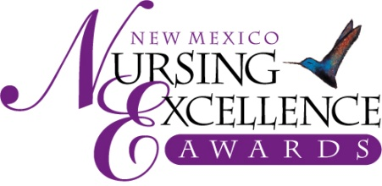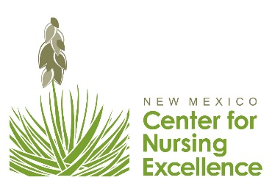

Education/Research/Academia
2021 Nomination Criteria – For Review Only

Education/Research/Academia | Academic faculty, in-service, continuing education, staff development; focus in non-clinical/clinical settings; research.

NOMINATION CRITERIA for Education/Research/Academia

1. How does this nurse share knowledge and inspire students/colleagues to pursue critical thinking, technical, relationship, and leadership skills needed to practice effectively as nurses? (30%)

- Role models
- Mentors
- Accessibility
- Enthusiasm

2. How has this nurse made significant contributions in education, professional development, and/or long term learning of nursing professionals? or How has this nurse made exceptional efforts to successfully transform educational offerings into engaging and accessible remote teaching platforms while maintaining an exceptional standard of quality? (25%)

3. How does this nurse remain current with state of the art technical innovations, latest critical thinking methodologies, and relationship building skills? (20%)

4. How does this nurse encourage innovation and contribute to the healthcare team? (15%)

5. Does this nurse conduct research or implement researched best practices which impact nursing practice? (10%)
- Immediate colleagues/co-workers
- Facility wide, and professional community
- Community service/publications

NOTE: A nurse may not be nominated again in the same category in which they have won previously.

Nominations are Due September 3, 2021

Only Online Submissions will be Accepted – Submit nominations at www.NMNursingExcellence.org/Nursing-Excellence-Awards

Please email the NM Center for Nursing Excellence at admin@nmcne.org with any questions

New Mexico Nursing Excellence Awards
Saturday, October 23rd, Hotel Albuquerque at Old Town

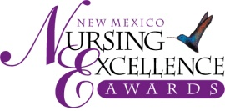 2021 Nursing Excellence Awards – Example Nomination

(Use this form for nominations in the Education/Research/Academia category)
Deadline for submission: Friday, September 3rd

Information about Nominee

Nomination Category

Nominee Name: LAST FIRST (no nicknames) MI

Employer/Organization Job Title

Degrees/Credentials (RN, LPN, etc.) Nominee NM resident 8/20-8/21? YES

(Consideration may be given to a nurse who is not a NM resident if that nurse is primarily employed in NM. Contact us at admin@nmcne.org with questions)

Complete Work Address

Personal Mailing Address
(We send congratulatory letter and would like to have nominee’s home address)

Daytime Phone Email (req.)

Information about Nominator

Nominated By

Business/Organization/Affiliation

Nominator’s Complete Address:

Daytime Phone Email

Professional Reference
(Must be from the nominee’s current work organization)

Name:

Duty Title:

Organization: Daytime Phone: Email:

Nominee Biography
(Please confine information to this form. No attached resumes will be accepted.)

Nominee Name:
Credentials:
Present Position/Job Title:
Education (include basic preparation through highest degree held)

Degree Awarded Major Area of Study Year Degree Awarded

Number of years as nurse:

Work Experience
Job Title Dates

Committees:
Professional Organizations:
Community Activities: (If applicable)
Publications (Provide latest publication and total number published):
Awards:

Instructions:
After filling out both pages of this form, please provide a summary of no more than 2 pages, double-spaced, in 12-point-font, describing why you feel this nominee deserves the New Mexico Nursing Excellence Award. NOTE: If over 2 pages, only the first 2 pages will be eligible for review. Please cite specific examples of accomplishments referring to the criteria listed for the specific award category. Describe how the person demonstrates caring that goes beyond the expected behaviors associated with providing competent and compassionate nursing care. (See “Tips for Completing a Successful Nomination”) You may use the formatted pages following or compose your own summary as long as the criteria are addressed.

In order for nominee to be considered for this award, all information requested must be provided. This includes:
- This nomination form (both sides), to include the nominee info and nominee biography
- A 2-page summary of accomplishments, using nomination criteria for category;
- Payment of $75 nomination fee (to cover nominee’s dinner at awards ceremony)

If a nomination category is not identified, the New Mexico Nursing Excellence Award Selection Committee will select a category based on the information provided. Also, the Committee reserves the right to place nominees in the category that best fits their nomination and/or enhances the nominee’s ability to compete for the award.

We list the criteria so you may address each one in your narrative.
Remember - specific examples are a great way to share the nurse’s contributions and show how the nurse meets the criteria.
You may write essay on this form or attach to form.

Please note the percentage/weight given to each criterion and please address all criteria in writing your essay.

1. How does this nurse share knowledge and inspire students/colleagues to pursue critical thinking, technical, relationship, and leadership skills needed to practice effectively as nurses? (30%)

2. How has this nurse made significant contributions in education, professional development, and/or long term learning of nursing professionals? or How has this nurse made exceptional efforts to successfully transform educational offerings into engaging and accessible remote teaching platforms while maintaining an exceptional standard of quality? (25%)

3. How does this nurse remain current with state of the art technical innovations, latest critical thinking methodologies, and relationship building skills? (20%)

4. How does this nurse encourage innovation and contribute to the healthcare team? (15%)

5. Does this nurse conduct research or implement researched best practices which impact nursing practice? (10%)

