2021 Nightingale Scholarships

General Nursing Scholarship Criteria and Guidelines

Application Requirement

In addition to filling out and submitting a scholarship application, all applicants must:

- Be a resident of New Mexico (or, if member of Navajo Nation, serve NM residents)

- Have successfully completed a minimum of one semester or 6-8 credit hours of nursing courses in your current nursing program. (ADN, BSN, RN-to-BSN, MSN, post-graduate nursing degree)

All pre-licensure nursing programs must be approved by the New Mexico Board of Nursing.
(For a complete list of approved NM schools, please visit the NM Board of Nursing website at http://www.bon.state.nm.us) If the nursing school is outside New Mexico, plans for the student to practice in New Mexico upon graduation must be stated in the applicant’s essay.

3. Submit proof of academic ability.
  - Maintain at least an overall (not just nursing courses) grade point average (GPA) of 3.0 on a 4.0 scale.
  - Submit copy of current grade transcript with application. Transcript/s must include school name and applicant name. No need to send grades from previous degrees obtained.

- Present evidence of leadership and character references.
- Include two letters of recommendation. One of the letters must be from current nursing faculty and/or academic advisor.
- We suggest you provide a copy of Tips for Writing a Letter of Recommendation on page 4 to those faculty or advisors writing your letters of recommendation. Letters of recommendation will be scored as follows: No letter = 0, Neutral/Factual = 0, Positive = 1, Enthusiastic = 2

- A personal statement in brief essay form identifying why the applicant chose the nursing profession or is continuing their nursing education and why the applicant needs the scholarship. If the school is outside New Mexico, plans to practice in New Mexico must be stated in the applicant’s essay. Essays will be scored as follows: Total all that apply: Articulate/clear/concise = 1, Focus/Service = 1, Focus/Self = 1

General Administrative Guidelines

- Completed applications for scholarship award must emailed to the New Mexico Center for Nursing Excellence no later than February 19, 2021.

Applications must be completed online at https://www.nmnursingexcellence.org/nightingale-scholarship
Questions? Call 505-565-5811 or email admin@nmcne.org

- Scholarship monies will be paid directly to the individual via a check sent to the director of their nursing program for those in pre-licensure programs.

- Applicants are responsible for meeting all requirements and submitting all materials by deadline.

- Applicants may reapply in subsequent years.

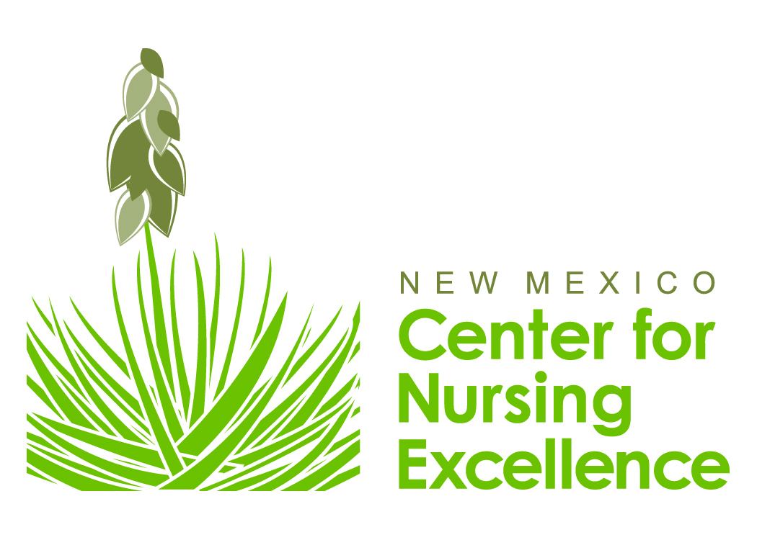
2021 Nightingale Scholarship – General Application

Please print or type. Date of Application_________________

Full Name_______________________________________________________________________
(First) (Middle) (Last)

Present Address__________________________________________________________________

(City)_______________________________________ (State) _________ (Zip) ________________

Phone (Home) _______________________________ (Cell) _______________________________

BEST Email address ______________________________________________________________

Permanent Address (if different) _______________________________________________________
(City)_______________________________________ (State) _________ (Zip) ________________

Community/School Activities:
Please list and describe any service-oriented community, healthcare, and/or school activities in which you participate. (Attach separate page if additional space is needed.)
______________________________________________________________________________________________________________________________________________________________________________________________________________________________
You will be scored for the following: Involved in service-oriented school-community activities = 2; Involved in community/ school activities only = 1; No involvement = 0

Information about the program you are attending:
Check the Nursing Program in which you are currently enrolled:
[ ] ADN [ ] BSN [ ] RN-to-BSN [ ] MSN [ ] DNP [ ] PhD

Nursing School/College____________________________________________________________
Address ________________________________________________________________________
Telephone Number________________________________________________________________
Name of Director/Dean/Chair________________________________________________________
Email address ___________________________________________________
Currently enrolled in what term/level of program? ____________________

Please include/attach a typed essay, up to 2 pages in length (single-sided, double-spaced),
in which you describe the reason you chose the nursing profession,
your personal and professional goals and why you are applying for this scholarship.
If the school you attend is outside of New Mexico or online,
please include in your essay your plans for practicing in New Mexico.

Financial Information:
Are you currently employed? Yes___ No___
If yes, where do you work? ___________________________________________________________
_________________________________________________________________________________
How many hours per week do you work? ______
Are you financially independent from your parents? Yes_____ No_____
Are you head of household? Yes_____ No_____

Do you currently have, or do you plan to apply for, one or more of the following types of financial assistance to defray the cost of your education?

Source of Assistance Currently Have Plan to Apply
Pell (Federal grant) _____________ ___________
GSL (Guaranteed Student Loan) _____________ ___________
DVR (Division of Vocational Rehab) _____________ ___________
EDD (Employment Development Office _____________ ___________
BIA (Bureau of Indian Affairs) _____________ ___________
SEOG (Supplemental Educational Opportunity Grant) _____________ ___________
SIG (Student Incentive Grant) _____________ ___________
NSL (Nursing Student Loan) _____________ ___________
Work/Study _____________ ___________
Service Organizations (Women’s/Men’s Clubs, Kiwanis, etc) _____________ ___________
IHS (Indian Health Service) _____________ ___________
Tribal _____________ ___________

Other (Please list) __________________________________________________________

Dependents:
Please list age and relationship of children and/or adult dependents living at home:

Age Relationship

______________________________________________________________________
______________________________________________________________________
______________________________________________________________________
Need index will be scored as follows (more than one may apply): Head of household=1; Employed full or Part time=1 Dependents=1; Other: Define=1

To be considered for award you must include the following
with your completed application:

[ ] Transcript of grades (Must include school name/s and applicants name)
[ ] Two Letters of recommendation
[ ] Essay (no longer than two pages)

All of the information provided in this application is, to the best of my knowledge, accurate and truthful.

_________________________________________________ _____________________
Electronic signature of applicant Date

TIPS FOR WRITING A LETTER OF RECOMMENDATION

NM Center for Nursing Excellence Nightingale Scholarship

You have been requested to write a letter of recommendation for a nursing student applying for a
NM Center for Nursing Excellence Nightingale Scholarship.

Scholarships are awarded based on:
- Academic achievement (Applicant must have an overall grade point average [GPA] of
at least 3.0 on a 4.0 scale)
- An essay written by the applicant on why they have chosen nursing as their area of study
- Character references (2)
- Financial need

Because the committee makes decisions based on information provided, it is helpful for the committee to have the following information in your letter of recommendation:
- Context that you know the student (i.e. what is your relationship – clinical practice rotation, didactic course, faculty advisor, etc.)
- How long you have known the student
- Characteristics you can highlight about this student (caring, leadership, commitment to the profession, clinical excellence, etc.)
- What else should we know about this student

